Stages of mitosis
Watch the youtube video “Mitosis made easy animation”. In the video each of the five stages of mitosis will be explained. During or after the video complete the following tasks.
- Complete the right hand column for each of the stages ( 1 or 2 key sentences)
- Complete the right hand column for the additional two stages of a cell life (cytokinesis and interphase – 1 sentences each)
- Cut and paste the appropriate diagram from the bottom of the page into the second column

Phase | Diagram | Description of what happens
Prophase
Prometaphase
Metaphase
Anaphase
Telophase
Cytokinesis
Interphase

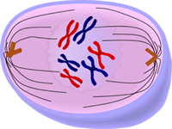
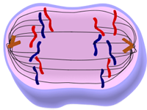
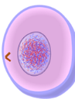
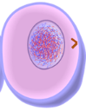
R
W
Z

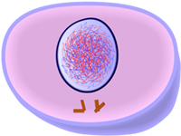
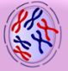
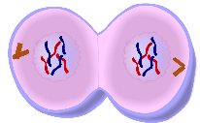

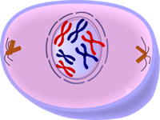

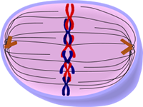
G
H
T
O

